
Flumes: Theory & Application
(.doc) (.pdf)

Abstract 2
Prelude 3
Selecting a Primary Measuring Device: Weir vs. Flume 4
Critical Flow Theory 5
Energy Equation Applied to Open-Channel Flow
Specific Energy
Characteristics of Critical Flow
Theory Applied to Flumes 13
General Discharge Vs. Head Formula
Submergence
Flume Classes 16
Long-Throated Flumes
Short-Throated Flumes
Other Special Flumes 18
Parshall Flumes
Background
Operation
Advantages
Disadvantages
Design
Discharge Calculation
Parshall Flume in Biosolids Project
H-Flumes
Cutthroat Flumes
Palmer-Bowles Flumes
Trapezoidal Flumes
Quick Selection Guide
Site Characteristics Related to Locating & Setting Flumes 31
Approach Conditions
Channel Flow Characteristics and Operational Needs
Erosion and Scour
workmanship 34
Acknowledgements 35
References 36
Abstract

The primary objective of writing a paper that describes the theory underlying flow in flumes is acquainting the reader with the flow-measuring device upon which most our samplers are based. A basic derivation of the formulas governing critical flow in flumes is presented and followed by a concise description of the different classes of flumes and their modes of design, operation, and installation. Finally, a case study of the PVC flumes constructed for the C-11653 Biosolids Project is presented as a sample application of the published empirical dimensions and discharge equations listed earlier.

Prelude

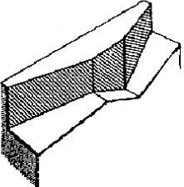
Flumes are open-channel flow sections that force flow to accelerate. Acceleration is produced by converging the sidewalls, raising the bottom, or a combination of both. When only the bottom is raised with no side contractions, the flume is commonly called a broad-crested weir. When the downstream depth is shallow and enough convergence exists between the upstream and downstream channels, the flow passes through critical depth. Therefore, flumes are sometimes called critical-depth flumes. When flow passes through critical depth, a unique water surface profile occurs within the flume or broad-crested weir for each discharge. This condition is known as free flow. For this case, upstream heads at one location relative to the control bottom elevation near the region of critical depth can be used to determine a usable head versus discharge relationship for flow measurement.
Flow

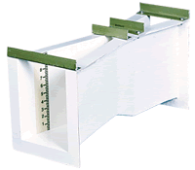
Flume head loss is less than about one-fourth of that needed to operate a sharp-crested weir having the same control width, and in some long-throated flumes, may be as low as one-tenth. Another advantage compared to most standard weirs is that for a properly designed and installed flume, the velocity of approach is a part of the calibration equations. Unauthorized altering of the dimensions of constructed flumes to obtain an unfair share of water is difficult and, therefore, not likely. Velocity of flow can usually be designed to minimize sediment deposition within the structure. Gradual convergence sections at the entrance tend to improve velocity distribution of approach flow and the passage of floating debris. Some flumes can be more expensive than sharp-crested weirs or submerged orifices in unlined channels.

Selecting a Primary Measuring Device: Weir vs. Flume

The selection of a primary measuring device for a particular flow measurement installation usually involves a series of three decisions:
- Which primary measuring device to use: a weir or a flume?
- Which specific type of primary device to use?
- What is the exact size of the primary device to be installed at the location in question?
Weirs and flumes each have decided advantages and disadvantages. A weir is the simplest device that can be used to measure flow in open channels. It is low in cost, relatively easy to install, and quite accurate when properly used. However, it normally operates with a rather significant loss in head, and its accuracy can be affected by variations in the approach velocity of the liquid in the flow channel. Moreover, it must also be periodically cleaned to prevent deposits of sediment or solids in the upstream side of the wear, which will adversely affect its accuracy.
On the other hand, a flume tends to be self-cleaning since the velocity of flow through it is high and there is no obstruction across the channel. It can also operate with a much smaller head loss than a weir, which can be important for many for many applications where the available head is limited. In addition, a flume is relatively less sensitive to varying approach velocity. Nonetheless, a fume is much more costly than a weir, and its installation is more difficult and time consuming. Flumes are also generally less accurate that weirs.
It should be noted that the initial installation cost is not the only expense that should be considered when choosing a primary device. As mentioned earlier, flumes tend to be self-cleaning, whereas weirs must be periodically cleaned. Lower maintenance costs associated with a flume may eventually outweigh the higher initial cost.

Critical Flow Theory
In reference to J. A. Robertson & C. T. Crowe, “Engineering Fluid Mechanics – 6th Edition”, 1997

- Energy Equation Applied to Open-Channel Flow

The one-dimensional energy equation for open channels (see Fig. 1-a) is:

$$\frac{p_{1}}{γ}+α_{1}\frac{v_{1}^{2}}{2g}+z_{1}=\frac{p_{2}}{γ}+α_{2}\frac{v_{2}^{2}}{2g}+z_{2}$$
(1)

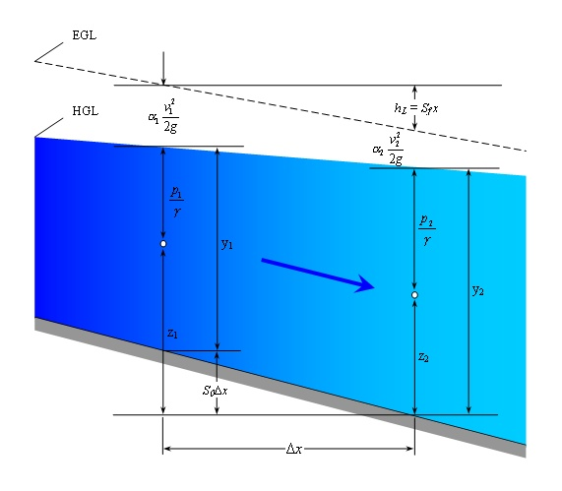

Figure 1-a

It’s evident from Fig. 1-a that the following equalities hold:

$$\frac{p_{1}}{γ}+z_{1}=y_{1}+S_{0}Δ_{x}\text{ and }\frac{p_{2}}{γ}+z_{2}=y_{2}$$

Where S₀ is the slope of the channel bottom, and y is the depth of flow. Assuming α₁ = α₂ = 1, we can write Eq. (1) as:

$$y_{1}+\frac{v_{1}^{2}}{2g}+S_{0}Δ_{x}=y_{2}+\frac{v_{2}^{2}}{2g}+h_{L}$$
(2)

Considering the special case where the channel bottom is horizontal (S₀ = 0) and head loss is negligible (h_{L} = 0), Eq. (2) becomes:

$$y_{1}+\frac{v_{1}^{2}}{2g}=y_{2}+\frac{v_{2}^{2}}{2g}$$
(3)

- Specific Energy

The sum of the depth of flow and the velocity head is defined as specific energy:

$$E=y+\frac{v^{2}}{2g}$$
(4)

Thus Eq. (3) states that the specific energy at section 1 is equal to the specific energy at section 2. The continuity equation between section 1 and 2 is:

$$A_{1}V_{1}=A_{2}V_{2}=Q$$
(5)

Accordingly, Eq. (3) can be expressed as:

$$y_{1}+\frac{Q^{2}}{2{\text{gA}}_{1}^{2}}=y_{2}+\frac{Q^{2}}{2{\text{gA}}_{2}^{2}}$$
(6)

Since A₁ & A₂ are both functions of the depth y, the magnitude of the specific energy at the section 1 or 2 is solely a function of the depth at each section. If, for a given channel and given discharge, depth versus specific energy is plotted, a relationship such as that shown in Fig. 1-b is obtained.

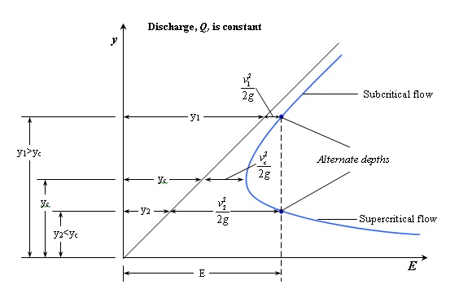
Figure 1-b

For a given value of specific energy, we can see that the depth may be either large or small. Physically, this means that for the small depth, the bulk of the flow energy is in the form of kinetic energy (Q²/2gA²); whereas for a larger depth, most of the energy is in the form of potential energy.

Flow under a sluice gate (Fig. 1-c) is an example of flow in which two depths occur for a given value of specific energy. The large depth and low kinetic energy occurs upstream of the gate, while the low depth and large kinetic energy occurs downstream. The depths are called alternate depths.

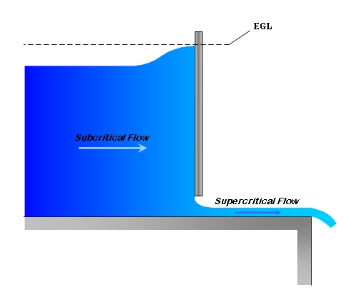

Figure 1-c

If we maintain the same rate of flow but set the gate with a larger opening, the upstream depth will drop, and the downstream depth will rise. Thus we have different alternate depths and a smaller value of specific energy than before. This is consistent with the diagram in Fig. 1-b.

Finally, it can be seen in Fig. 1-b that a point will be reached where the specific energy is minimum and only a single depth occurs. At this point, the flow is termed critical. Thus one definition of critical flow is the flow that occurs when the specific energy is minimal for a given discharge. The flow for which the depth is less than critical is (velocity is greater than critical) is termed supercritical flow, and the flow for which the flow is greater than critical is termed subcritical flow. In Fig. 1-c, subcritical flow occurs upstream and supercritical flow occurs downstream of the sluice gate. (It should be noted that some engineers refer to subcritical and supercritical flow as tranquil and rapid flow.)

- Characteristic of Critical Flow

It has been proven that critical flow occurs when the specific energy is minimum for a given discharge. The depth for this condition may be determined if we solve for dE/dy from E = y + Q²/2gA² and set dE/dy equal to zero:

$$\frac{\text{dE}}{\text{dy}}=1−\frac{Q^{2}}{{\text{gA}}^{3}}⋅\frac{\text{dA}}{\text{dy}}$$
(7)

However, dA = Tdy, where T is the width of the channel at the water surface. Then Eq. (7), with dE/dy = 0, will reduce to:

$$\frac{Q^{2}T_{c}}{{\text{gA}}_{c}^{3}}=1\text{ and }\frac{A_{c}}{T_{c}}=\frac{Q^{2}}{{\text{gA}}_{c}^{2}}$$
(8,9)

Introducing the hydraulic depth D, which is defined as A/T, then Eq. (9) becomes:

$$D_{c}=\frac{Q^{2}}{{\text{gA}}_{c}^{2}}=\frac{v^{2}}{g}$$
(10,11)

Upon dividing Eq. (11) by D_{c} and taking the square root of it, we get

$$1=\frac{v}{\sqrt{{\text{gD}}_{c}}}$$
(12)

In open channel hydraulics, the Froude number is a very important nondimensional parameter. The Froude number, Fr, is the ratio of inertia force to gravity force, which simplifies to:

$$\text{Fr}=\frac{v}{\sqrt{{\text{gD}}_{c}}}=1$$

(The Froude number is equal to unity when critical flow prevails. If the Froude number is less than unity, the flow is subcritical and has a low velocity, which is often described as tranquil and streaming. On the other hand, if the Froude number is greater than unity, the flow is supercritical and has a high velocity, which is usually described as rapid, shooting, and torrential.)

If a channel is of rectangular cross section (as in the case of a Parshall Flume), then A/T is the actual depth, and Q²A² = q²/y², so the formula for critical depth, Eq. (9), becomes:

$$y_{c}={\left(\frac{q^{2}}{g}\right)}^{\frac{1}{3}}$$
(13)

Were q is the discharge per unit width of the channel.

Critical flow may also be examined in terms of how the discharge in a channel varies with depth for a given specific energy. For example, consider in a rectangular channel where

$$E=y+\frac{Q^{2}}{2{\text{gA}}^{2}}=y+\frac{Q^{2}}{2{\text{gy}}^{2}B^{2}}$$

If we consider a unit width of the channel and let q = Q/B, then the above equation becomes

$$E=y+\frac{q^{2}}{2{\text{gy}}^{2}}$$

If we determine how q varies with y for a constant value of specific energy, we see that the critical flow occurs when the discharge is maximum (see Fig. 1-d)

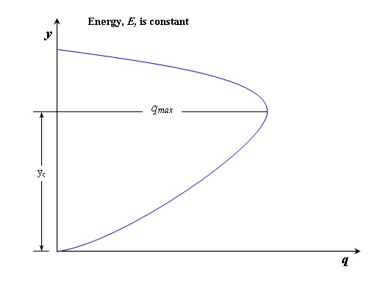
Figure 1-d

Originally, the term critical flow probably related to the unstable character of the flow for this condition. Referring to Fig. 1-b, we notice that only a slight change in specific energy will cause the depth to increase or decrease a significant amount; this is a very unstable condition. In fact, observations of critical flow in open channels show that the water surface consists of a series of standing waves. Because of the unstable nature of the depth in critical flow, designing canals so that normal depth is either well above or well below critical depth is usually best. The flow in canals and rivers is usually subcritical; however, the flow in steep chutes or over spillways is supercritical.

Theory Applied to Flumes

Flumes are designed to force a transition from sub-critical to super-critical flow. The transition is caused by designing flumes to have a narrowing at the throat, raising of the channel bottom, or both. Such a transition causes flow to pass through critical depth at the flume throat. At the critical depth, energy is minimized and there is a direct relationship between water depth and flow rate. However, it is physically very difficult to measure critical depth in a flume because its exact location is difficult to determine and may vary with flow rate. Through mass conversion, the upstream depth is related to the critical depth. Therefore, flow rate can be determined by measuring the upstream depth, which is a highly reliable measurement.

- General Discharge Vs. Head Formula

This equation and the specific energy equation are the basic critical flow relationships for any channel shape.

$$\frac{Q_{c^{2}}}{g}=\frac{A_{c^{3}}}{T_{c}} ∧ E=\frac{v^{2}}{2g}+y$$

In order to derive the basic form of the discharge equation for various flumes, assume that we have a channel of rectangular cross section. As mentioned earlier, all flumes are designed with the intent of producing critical depth in the flume throat and thereby creating a unique depth-discharge relationship. If this critical depth is measured, the rate of flow can easily be computed from:

$$q=\sqrt{{\text{gy}}_{c^{3}}}⇒Q=B\sqrt{{\text{gy}}_{c^{3}}}$$

where B is the width of the channel normal to the flow direction.

Because y_{c}/2 = v²_{c} /(2g), it is easily shown that y_{c} = 2/3E, where again, E is the total head, y + v²_{approach} /(2g); hence the preceding equation can be written as:

$$Q=B\sqrt{g}{\left(\frac{2}{3}\right)}^{\frac{3}{2}}E^{\frac{3}{2}}⇒Q=0\text{.}\text{385}B\sqrt{2g}E_{c^{3/2}}$$
(13)

Had the velocity of approach been neglected, the equation can be rewritten as:

$$Q_{\text{Theoretical}}=0\text{.}\text{385}B\sqrt{2g}H^{3/2}$$

If the height of the flume is relatively small, then the velocity of approach may be significant and the discharge produced will be greater than that given by the preceding equation. To account for these effects, a discharge coefficient C is defined as:

$$C=\frac{Q}{Q_{\text{Theoretical}}}$$

Then

$$Q=0\text{.}\text{385}\text{CB}\sqrt{2g}H^{3/2}$$
(14)

This sums up the basic derivation of the discharge vs. head formula for most flumes. However, extensive experimental research has been done and most flumes have a published set of empirical formulas that are function of channel widths or other key dimensions. In the case of the Parshall flume, for example, different flume widths (with the corresponding different dimensions) had their discharge vs. head results plotted and fitted to power functions with K and n as the variable parameters. Replacing the constant parts of Eq. (14) by K (which also encompasses the throat width), and n as the head power (a value that circulates around 1.5) the general formula becomes:

$Q={\text{KH}}^{n}$
(15)

The various contributing variables to this formula are the velocity of approach, channel width, non-horizontal channel bottom, and the desired units. This generalized equation is to be elaborately discussed in the to the Parshall flume section of this paper.

- Submergence
All flumes have a minimum needed head loss to assure that free flow exists and that only an upstream head measurement is needed to determine discharge rate. This required head loss is usually expressed as a submergence limit defined by the ratio of the downstream head to the upstream head, both referenced to the flume throat bottom. The term "modular limit" is defined as this limiting submergence ratio for a particular flow module, which causes no more than a 1% deviation in the upstream head reading for a given discharge. When these limits are exceeded, an additional downstream head measurement is sometimes used to extend the measurement range of a flume, particularly for Parshall and cutthroat flumes, but at considerable loss of accuracy. Submergence also increases upstream channel depth, decreasing the upstream velocity, which may aggravate sedimentation problems.
Flume Classes

As mentioned earlier, the two basic classes or forms of flumes are long-throated flumes and short-throated flumes; they are discussed in depth below:

- Long-Throated Flumes:
Long-throated flumes (Fig. 2-a) control discharge rate in a throat that is long enough to cause nearly parallel flow lines in the region of flow control. Parallel flow allows these flumes to be accurately rated by analysis using fluid flow concepts (energy principle, critical depth relationships, and boundary layer theory). Long-throated flumes can have nearly any desired cross-sectional shape and can be custom fitted into most canal-site geometries. The modified broad-crested weirs, also called ramp flumes, are styles of long-throated flumes.
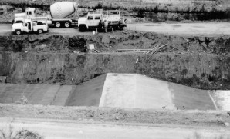
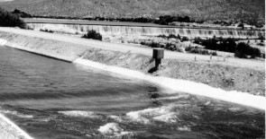
Long-throated flume (broad-crested weir) under construction.
The long-throated flume (broad-crested weir) with approximately 1,200 ft³/s.
Water Resources Research Laboratory, “Water Measurement Manual – 3rd Edition” Figure 2-a

- Short-Throated Flumes:
Short-throated flumes are considered short because they control flow in a region that produces curvilinear flow. Although they may be termed short throated, the overall specified length of the finished structure, including transitions, might be relatively long. The Parshall flume is the most common example of this type of flume (Fig. 2-b). These flumes would require detailed and accurate knowledge of the individual streamline curvatures for calculated ratings, which is usually considered impractical. Thus, calibrations for shortthroated flumes are determined empirically by comparison with other more precise and accurate water measuring systems.

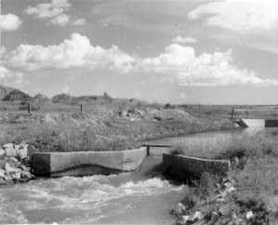
Figure 2
The long-throated flume (broad-crested weir) with approximately 1,200 ft³/s.
“Water Measurement Manual – 3rd Edition” Figure 2-b

Other Special Flumes
Most tables and diagrams are from Grant & Dawson, “ISCO Open Channel Flow Measurement Handbook – 5th Edition”, 1998.

Most flumes in common use today can be traced to one of three early design sources: rectangular English flumes based upon early work in India around 1908-1914; the Parshall flume whose forerunner, a Venturi flume developed by Cone, was extensively modified and tested by Parshall; and flumes of the type first developed by Palmer and Bowles. The follow section will concisely discuss some of the more popular flume designs currently in use. Included are discussions of the H-flume, Cutthroat flume, Palmer-Bowles, the trapezoidal flume, and a detailed discussion of the Parshall Flume.

- Parshall Flumes (in depth):

- Background:

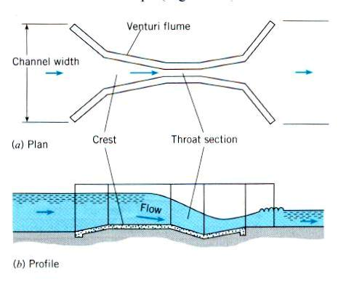
A very common critical-flow flume is the Venturi Flume (see Figure 1.), which was developed and calibrated by Dr. Parshall of the U.S. Soil Conservation Service in1922. The essential change introduced by Parshall was a drop in the floor, which produced supercritical flow through the throat of the flume. This seemingly perfected device was named the Parshall Measuring Flume, which is not patented and the discharge tables are not copyrighted.

- Operation:

The constricted throat of the flume produces a head that is related to discharge. The level of converging section followed by the downward sloping floor in the throat gives the Parshall flume its ability to withstand relatively high degrees of submergence without affecting the rate of flow. The converging upstream portion of the flow accelerates the entering flow, helping to eliminate deposits of sediments, which would otherwise reduce measurement accuracy. The approaching flow should be relatively free of turbulence, eddies, and waves if accurate measurements are expected.

- Advantages:

The principal advantages of the Parshall flume are its capabilities for self-cleaning (particularly when compared with weirs), its relatively low head loss, and its ability to function over a wide operating range while requiring only a single head measurement. These characteristics of the Parshall flume make it particularly suitable for flow measurement in irrigation canals, certain natural channels, and sewers.

- Disadvantages:

Parshall flumes have gone out of favor due to their construction complexity and likelihood to trap sediment compared to newer flume designs. The rectangular and trapezoidal flumes, for example, are simpler to construct, can be more easily fit into an existing channel, and can trap less sediment than a Parshall flume. However, the methodology relating discharge to measured head is more complex.

Although Parshall flumes are in extensive use in many western irrigation projects, they are no longer generally recommended. Some states specify the use of Parshall flumes by law for certain situations.

- Design:

Parshall flume sizes are designated by the throat width, W, as shown in Fig. 3-a. Dimensions are available for flumes with throat widths ranging from 1” to 50ft. The configuration and standard nomenclature is also given in Fig. 3-a. For a given throat width W, all other dimensions are rigidly prescribed.

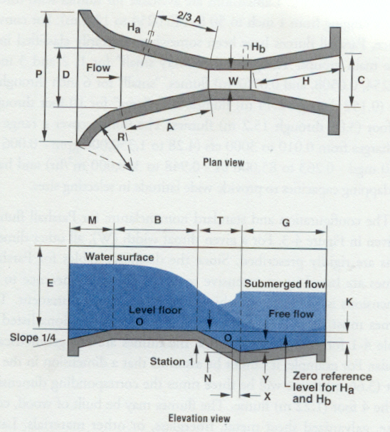
ISCO Open Channel Flow Measurement Handbook – 5th Edition Figure 3-a

Since the discharge tables for Parshall flumes are based on extensive research, faithful adherence to all dimensions is necessary to achieve accurate flow measurement. The flumes must be constructed according to the dimensions listed in Table. 3-a for each flume, because the flumes are not geometrically similar.

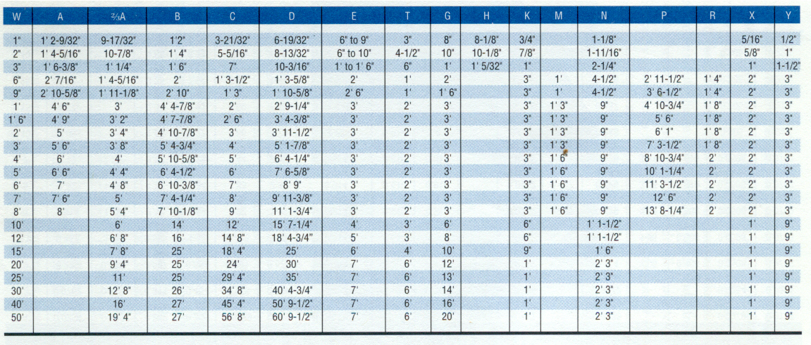
Table 1
ISCO Open Channel Flow Measurement Handbook – 5th Edition Table 3-a

- Discharge Calculation:

The general discharge (head vs. flow rate) equation of free flow through a Parshall flume takes the form:

$$Q={\text{KH}}^{n}$$

Where Q is the flow rate, H is the head measured at point H_{a} (see Fig. 3-a), K is a constant that depends on throat width & units, and n is a constant power that depends on throat width. Table. 3-b presents the discharge equations for a number of common Parshall flumes.

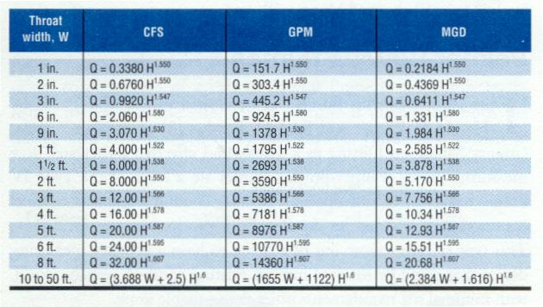
Table 1
ISCO Open Channel Flow Measurement Handbook – 5th Edition Table 3-b

- Parshall Flume in Biosolids Project:

Parshall flumes are not patented; therefore we custom designed our own flumes for the C-11653 Biosolids Project. However, it is absolutely necessary to abide by the published dimensions.

Our custom-built flumes are about 1 feet high and 3 feet long. Both the sidewalls and the bottom parts are made of PVC and joined with stainless steel screws. The sidewalls are made of ¾” PVC sheets, whereas the bottom parts are made of ½” PVC sheets. As to the most integral dimension, the throat is 2" wide, as illustrated in Fig 3-b.

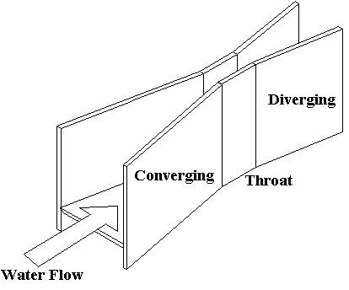
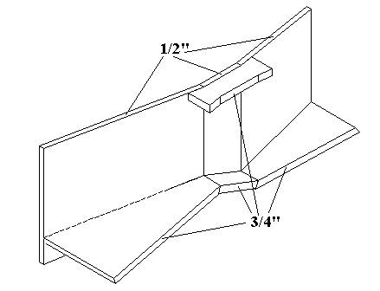
2”
Figure 2
Figure 3-b

As for the corresponding discharge equations, Table. 3-c sums up the equations to be used in different discharge units:

Units | Q in cfs & h in ft | Q in gpm & h in ft | Q in mgd & h in ft | Q in l/s & h in m | Q in m³/hr & h in m
Formula | Q=0.676h^{1.55} | Q=303.4h^{1.55} | Q=0.4369h^{1.55} | Q=120.7h^{1.55} | Q=434.6h^{1.55}
Table 3-c

Table 3
- H-Flumes:
H-flumes, developed by the Natural Resources Conservation Service (former known as the Soil Conservation Service), are made of simple trapezoidal flat surfaces. These surfaces are placed to form vertical converging sidewalls. The downstream edges of the trapezoidal sides slope upward toward the upstream approach, forming a notch that gets progressively wider with distance from the bottom. These flumes should not be submerged more than 30 percent. This group of flumes, including H-flumes, HS-flumes, and the HL-flumes has been used mostly on small agricultural watersheds and has not found extensive use in irrigation flow measurements.
Dimensional proportions of the H-type flumes are shown in Fig. 3-c. (Note that the dimensions are proportional to the maximum depth, D.)
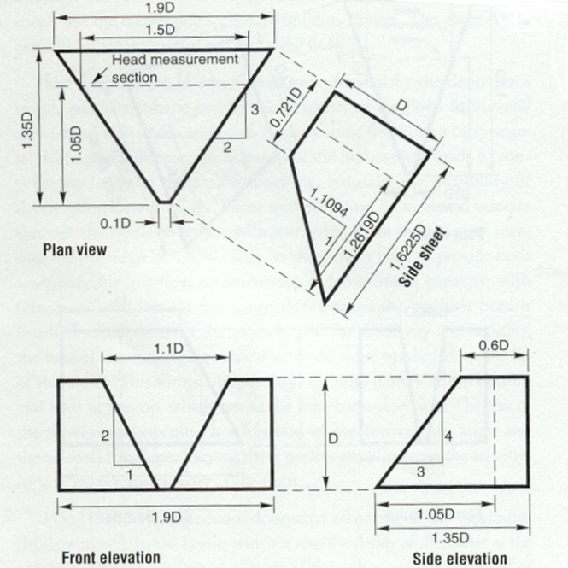
ISCO Open Channel Flow Measurement Handbook – 5th Edition Figure 3-c
Depth D
feet | meters
0.5 | 0.152
0.75 | 0.229
1.0 | 0.305
1.5 | 0.457
2.0 | 0.610
2.5 | 0.762
3.0 | 0.914
4.5 | 1.37

- Cutthroat Flumes:
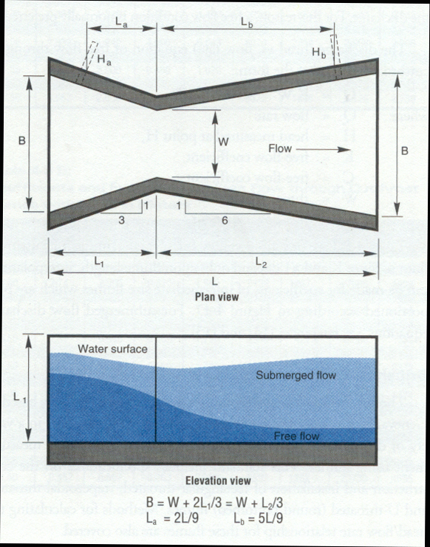
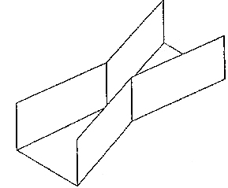
Cutthroat flumes are so named because they resemble Parshall flumes with the throat "cut out." They are formed by directly connecting a 6:1 converging section to a similar diverging section. Thus, they consist of a converging level inlet section with vertical sidewalls and a diverging level outlet section also with vertical sidewalls. They do not have any parallel walls forming a straight throat and, thus, belong to a class of throat less flumes. The converging and diverging walls do not necessarily match those of other flumes in either converging or diverging slope or length. The primary objective of their development was construction simplicity compared to Parshall flumes.
Figure 2
ISCO Open Channel Flow Measurement Handbook – 5th Edition Figure 3-d
Flow
However, the prescribed head measuring location, which may be in a zone of separation, and conditions of the upstream channel in which it is placed, along with variable conditions of the sharp connection of the convergence and the divergence, have caused considerable variability in calibrations. Because of these complexities in hydraulic behavior, several authors do not recommend their use.
A characteristic length, L, and a throat width, W, dimensionally define the rectangular cutthroat flume, shown in Fig. 3-d. As shown, all other flume dimensions can be derived from the two dimensions.
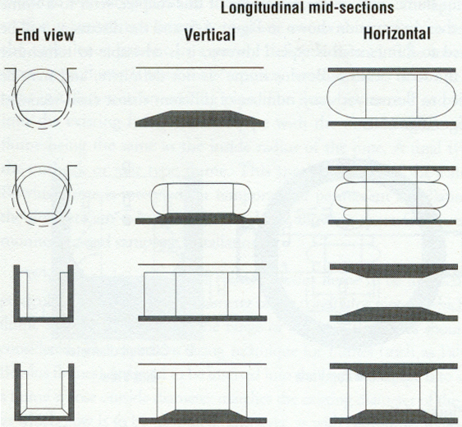
- Palmer-Bowles Flumes:
Figure 5
ISCO Open Channel Flow Measurement Handbook – 5th Edition
Figure 3-e
Palmer-Bowles flumes are frequently made as inserts with circular bottoms that conveniently fit into U-shaped channels or partially full pipes. These flumes make a transition from a circular bottom section to a raised trapezoidal throat and transition back to a circular bottom section. These flumes are of the long-throated type and can be calibrated by theoretical analysis.
The Palmer-Bowles flume is essentially a restriction in the channel designed to produce a higher velocity critical flow in the throat. The flume is most often used in manholes or open round or rectangular bottom channels to measure flow rate. It is useful in temporary installations to provide flow data for determining flume size and equipment requirements for permanent installation. Typical shapes of Palmer-Bowels flumes are shown for installation in round and rectangular conduits are shown in Fig. 3-e.
Some of the flume’s advantages include accuracy of measurement (comparable to Parshall flumes), low energy loss, and minimal restriction to flow. A principal advantage of the Palmer-Bowles flume is the comparative ease with which it can be installed in existing conduits, since it does not require a drop in the conduit invert as would be required with a Parshall flume. A disadvantage of Palmer-Bowles flumes is that they have a smaller useful range of flow rates than a Parshall flume, with a range that seldom exceeds twenty to one. Also, the resolution of the Palmer-Bowles flume is not as good as that of the Parshall flume. For a given change in flow rate, that Parshall flume produces a greater change head that does the Palmer-Bowles flume.
Palmer-Bowles flumes are usually purchased prefabricated from one of the many flume manufacturers. They are normally made of fiberglass, a reinforced plastic, or stainless steel. Palmer-Bowles flumes are available in a number of installation configurations as shown in Fig. 3-f.
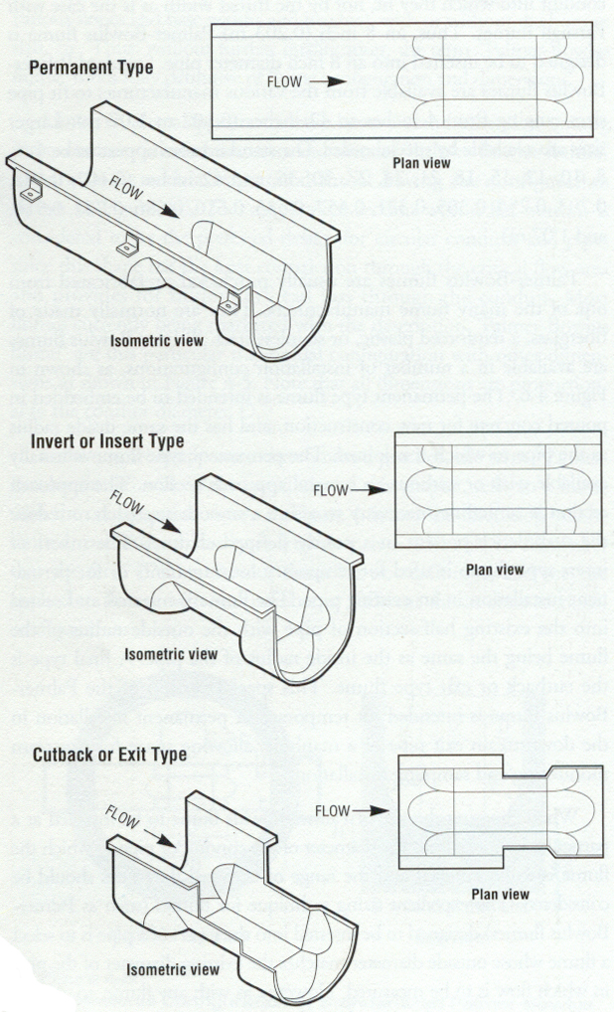
Figure 6
ISCO Open Channel Flow Measurement Handbook – 5th Edition Figure 3-f

- Trapezoidal Flumes:
The trapezoidal flume was developed primarily to measure flow in irrigation channels and has been used for many years by the Agricultural Research Service, U.S. Department of Agriculture. For agricultural applications, it is superior to Parshall-type flumes for a number of reasons, particularly for measuring smaller flows. The trapezoidal shape conforms to the normal shape of ditches, especially those that are lined. This minimizes the amount of transition section needed as compared to that required from a trapezoidal shape to a rectangular on and back to the trapezoidal. The trapezoidal one is also desirable since the sidewalls expand as the depth increases. This means that a trapezoidal flume can convey a larger range of flow rates since an incremental increase in flow produces a relatively small increase in depth because of the trapezoidal shape. An isometric view of a typical isometric flume is presented in Fig 3-g.
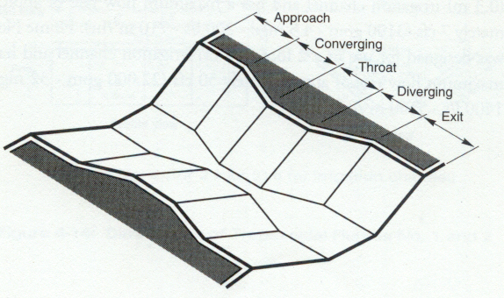
Figure 7
ISCO Open Channel Flow Measurement Handbook – 5th Edition Figure 3-g

Another primary characteristic of the trapezoidal flume is that it can operate under a higher degree of submergence than the Parshall flume without the need of corrections. Furthermore, the straight through bottom of the flume permits the flume to pass trash quite readily and reduces the problem of silt build-up upstream of the flume. A plan, profile, and end/throat section schematic are shown in Fig. 3-h.

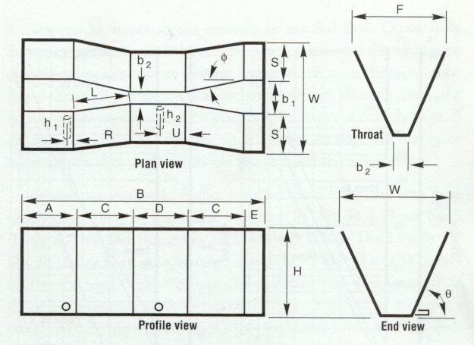
Figure 8
ISCO Open Channel Flow Measurement Handbook – 5th Edition Figure 3-h

- Quick Selection Guide:

Advantages of Flumes
- Self-cleaning to a certain degree
- Relatively low head loss
- Accuracy less affected by approach velocity than weirs
Disadvantages of Flumes
- High cost
- Difficult to install
Type of Flume | General Comments
- Parshall Flume | Most widely known and used flume for permanent installations. Available in throat widths ranging from 1” to 50ft to cover most flows. Fairly difficult installation requiring a drop in the conduit invert.
- H-Flume | Developed to measure agricultural runoff. Principal advantage is ability to measure wide range of flows with reasonable accuracy. Construction is fairly simple and flume is easily installed.
- Cutthroat Flume | Similar to Parshall flume, except that flat bottom does not require drop in conduit invert. Can function well with high degree of submergence. Flat bottom passes solids better than Parshall flume.
- Palmer-Bowles Flume | Flume designed to be easily installed in existing conduit. Good for portable or temporary installations, as not drop in conduit invert required. Widely used in sanitary field for measuring flow in manholes.
- Trapezoidal Flume | Developed to measure flows in irrigation channels. Principal advantage is ability to measure wide range of flows and also maintain good accuracy at low flows.

Site Characteristics Related to Locating & Setting Flumes
In reference to Water Resources Research Laboratory, “Water Measurement Manual – 3rd Edition”

Proper location of the flume is important from the standpoint of accuracy and ease of operation. For convenience, the flume should be located near the diversion point and near the regulating gates used to control the discharge. Flumes should be readily accessible by vehicle for both installation and maintenance purposes. All structures for measuring or regulating the rate of flow should be located in a channel reach where an accurate head can be measured. The survey of a channel to find a suitable location for a structure should also provide information on a number of relevant factors that influence the performance of a future structure.

- Approach Conditions:
Flumes should not be installed too close to turbulent flow, surging or unbalanced flow, or a poorly distributed velocity pattern. Poor flow conditions in the area just upstream from the measuring device can cause large discharge indication errors. In general, the approaching flow should be tranquil. Tranquil flow is defined as fully developed flow in long straight channels with mild slopes, free of curves, projections, and waves.
Studies of approach requirements for closed conduits have led to the acceptance of 10 diameters of straight pipe as sufficient for pipe meters claiming to be accurate to within 0.5 to 1 percent. By the usual hydraulic analogy, open channel flow would require 40 times the hydraulic radius of straight, unobstructed approach channel. The hydraulic radius is the area of flow section divided by the wetted perimeter, which becomes d/4 for full pipes; hence, the suggested 40 times hydraulic radius approach distance. These requirements can probably be relaxed because open channel measuring flumes claim accuracy to a wider margin of 2 to 5 percent. However, for a rectangular channel that is twice as wide as it is deep, 40 times the hydraulic radius is numerically equal to 10 top widths.
Approach velocities less than 1 foot per second (ft/s) encourage aquatic pests, insects, and sediment deposition, so the approach velocity should exceed 1 ft/s if at all practical. To prevent wave interference of head measurement, the Froude number of the approaching channel flow should be less than 0.5 for the full range of anticipated discharges and should not be exceeded over a distance of at least 30 times the measurement head before the structure.
It is recommended that a check be made of the approach velocity condition by current meter measurements, especially when using baffles. In any case, approach condition should be verified visually. Visual inspection should be made for obvious boils and backflows and unstable surface conditions.

- Channel Flow Characteristics and Operational Needs:
For accurate measurements, sufficient head loss must be created to obtain a unique discharge versus head relationship. This relationship assures that submergence limits have not been exceeded and modular flow exists. To prevent submergence altogether or to assure that excessive submergence does not occur, the designer needs to know whether the downstream water surface elevation relationships are consistent and do not change with season or whether they are influenced by operation of gates, reservoir operation, or other laterals. The channel water levels greatly influence the sill height necessary to keep the downstream water surface below the submergence limit, thus obtaining modular flow for the needed discharge range.
The amount of downstream flow resistance and, hence, the water surface elevation, is likely to vary with sediment deposits, debris, canal checking operations, vegetative growth, and aging. For a new design, careful assessment of friction, including the effects of relative roughness, is required. A thorough appraisal of needed canal operations is required to determine the frequency of measuring different discharges, including the normal design flow and the maximum design flow.
To select or design an appropriate flume for installation in an existing channel, full advantage should be taken of making field measurements at different discharges to obtain thorough knowledge of channel performance at the site. After tentatively selecting the flume location, information should be obtained on the maximum and minimum flows to be measured, the corresponding flow depths, the maximum velocity, and the dimensions of the channel at the site. These measurements should include channel widths, side slopes, depths, and the height of the upstream banks with special attention to their ability to contain the increased depth caused by the flume installation.

- Erosion And Scour:
Ideally, the selected channel reach should have a stable bottom elevation. In some channel reaches, sedimentation occurs in dry seasons or periods. These sediments may be eroded again during the wet season. Sedimentation may change approach velocity or may even bury the structure, and the erosion may undercut the foundation of the structure.
Based on the channel water levels and the required sill height, in combination with the discharge versus head relationship of the structure, ponding at the upstream structure should be assessed. Excessive ponding commonly causes sedimentation difficulties because of the subsequent reduction in the approach flow velocities. To avoid upstream sedimentation, the sill height plus the measuring head should be about the same as for the approach channel over as much of the discharge measuring range as practical. This arrangement will help reduce sedimentation upstream from the structure.
The required drop may exceed the capacity of soil-lined channels to resist scour, and foundations may scour. Thus, rock armoring may be needed to prevent undermining.

Workmanship
In reference to Water Resources Research Laboratory, “Water Measurement Manual – 3rd Edition”

Flumes require accurate workmanship for satisfactory performance. Short flumes will provide reasonably accurate flow measurements if the standard dimensions are attained during construction. For accurate flow measurement, the flow surfaces must be correctly set or placed at the proper elevation, the crest must be properly leveled, and the walls must be properly plumbed. Although long-throated flumes can be computer recalibrated using as-built dimensions to correct for moderate form slipping or errors of construction, correcting for throat-section slope in the direction of flow is not always satisfactory. In any case, adequate care during construction is preferable. The modified broad-crested weir flume has only one critical flow surface, and it is level.
Flumes should be set on a solid, watertight foundation to prevent leakage around and beneath the flume and prevent settlement or heaving. Collars or antiseep walls should be attached to either or both the upstream and downstream flanges of the flume and should extend well out into the channel banks and bottom to prevent bypass flow and foundation settlement caused by erosion. A stable foundation without significant settling or leakage must be secured at reasonable costs.
The flumes can be built of wood, concrete, galvanized sheet metal, or other materials. Large flumes are usually constructed on the site, but smaller flumes may be purchased as complete flumes and placed in one piece. Others are provided in bolt-together pieces, which are assembled onsite. Some of these flumes are made of lightweight materials, which are then made rigid and immobile by careful earth backfill or by placing concrete outside of the walls and beneath the bottom.
When making a number of relatively small concrete flumes of the same size, use of portable and knockdown reusable forms is economical and practical. These forms require high quality design and workmanship. Good construction practice should be used in placing footings, setting the forms, and pouring and tamping wall concrete to provide smooth surface finishes. Accuracy of the short flumes depends on correct flume dimensions, proper setting, and proper use. As flume size decreases, the influence of a small dimensional error becomes more prominent, and the importance of this care increases.

Acknowledgements

I am most appreciative of Mr. Tiago Silva’s assistance and undue patience while helping me on the “Flume in Biosolids Project” section of this paper.

References

- J. A. Robertson & C. T. Crowe, “Engineering Fluid Mechanics – 6th Edition”, 1997.

- D. M. Grant & B. D. Dawson, “ISCO Open Channel Flow Measurement Handbook – 5th Edition”, 1998.

- T. J. McGhee, “Water Supply and Sewerage – 6th Edition”, 1991.

- Water Resources Research Laboratory, “Water Measurement Manual – 3rd Edition”: http://www.usbr.gov/wrrl/fmt

- LMNO Engineering, Research, and Software, Ltd, “Flume Graphic Calculator Software”: http://www.lmnoeng.com/Flumes/flumes.htm

- T. F. Silva: “Flume Building”, : http://www.intellitemps.net/silva/

- O. Neumann: http://www.intellitemps.net/oneumann/prototyping%20frames.htm

